Name: Lab section: L01 Lab task: ______ /10

**Lab 4: Passive Filters**

**INTRODUCTION:**

In this lab, you will apply your knowledge on AC circuit analysis to some basic circuits with some resistors and capacitors. At the end of this lab, you will apply your knowledge of passive filters to a real application involving simple audio processing.

**Learning outcomes**

* Simulate frequency response
* Apply filters to perform simple audio processing

**Lab Task 1**

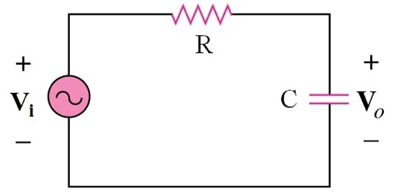

Fig 1: Schematic of a RC circuit.

1. Build the circuit in **Fig 1** in LTspice, where R and C are values announced at the beginning of the lab.

*R* = **3kΩ**

*C* = **6.8nF**

1. Right click at the voltage source and select “Advanced”. In “Small Signal Parameters”, input “1” in “AC Amplitude” to simulate AC of 1V peak amplitude.
2. Next, in “Analysis Command”, select “AC Analysis” instead of “Transient” in Lab 3. Select “Octave” in “Nature of Sweep” while input “Start frequency” and “Stop frequency” as “1” and “512e3” respectively to simulate a frequency sweep from 1 Hz to 512 kHz. You can input “100” or other numbers as the number of points per octave.
3. Run the simulation.
4. In the waveform viewer, you can change the y-axis scale by right-click the y-axis label and select “logarithmic” instead of “decibel”.

**Plot |*V*o | and the phase in the waveform viewer. Take a screenshot and insert the figure below.**

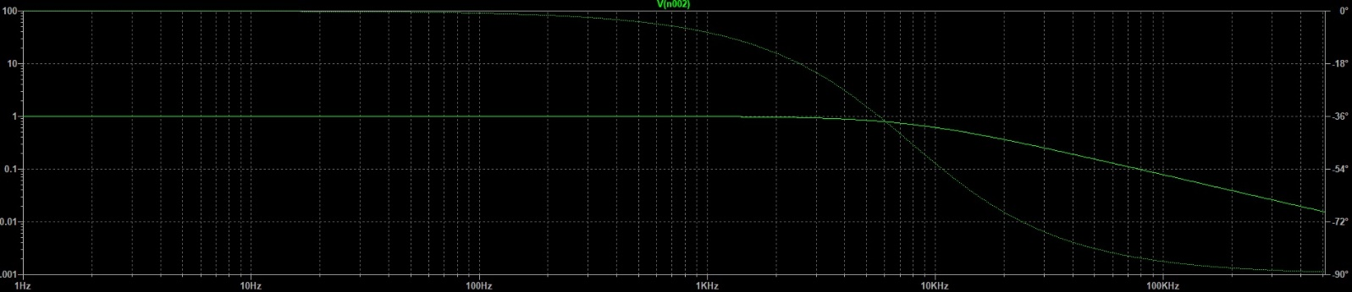

**The solid line corresponds to the |*V*o | and the dotted line corresponds to the phase. Take note of the phase of Vo relative to Vi at the lowest, highest and cutoff frequencies.**

**Table 1:** Simulation of frequency response for circuit of **Fig 1**

|  |  |  |
| --- | --- | --- |
| $$f$$ | $$V_{o} (V)$$ | $$Phase (V_{o}/V_{i})$$ |
| $$1 Hz$$ | $$0.99999999$$ | $$-0.007344°$$ |
| $$\frac{1}{2πRC}=7801.712897Hz$$ | $$0.70710752$$ | $$-44.999881°$$ |
| $$512 kHz$$ | $$0.015235952$$ | $$-89.12701°$$ |

**________ / 3**

**Lab Task 2**

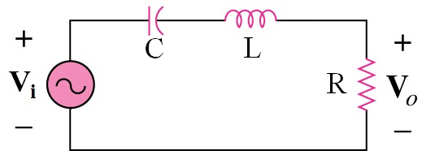

Fig 2: Schematic of a RLC circuit.

1. Build the circuit in **Fig 2** in LTspice, where R = 300Ω, L = 10mH and C = 6.8nF.
2. Right click at the voltage source and select “Advanced”. In “Small Signal Parameters”, input “10” in “AC Amplitude” to simulate AC of 10V peak amplitude.
3. Next, in “Analysis Command”, select “AC Analysis” instead of “Transient” in Lab 3. Select “Octave” in “Nature of Sweep” while input “Start frequency” and “Stop frequency” as “1e3” and “512e3” respectively to simulate a frequency sweep from 1 kHz to 512 kHz. You can input “100” or other numbers as the number of points per octave.
4. Run the simulation.
5. In the waveform viewer, you can change the y-axis scale by right-click the y-axis label and select “logarithmic” instead of “decibel”.

**Plot |*V*o | and the phase in the waveform viewer. Take a screenshot and insert the figure below.**

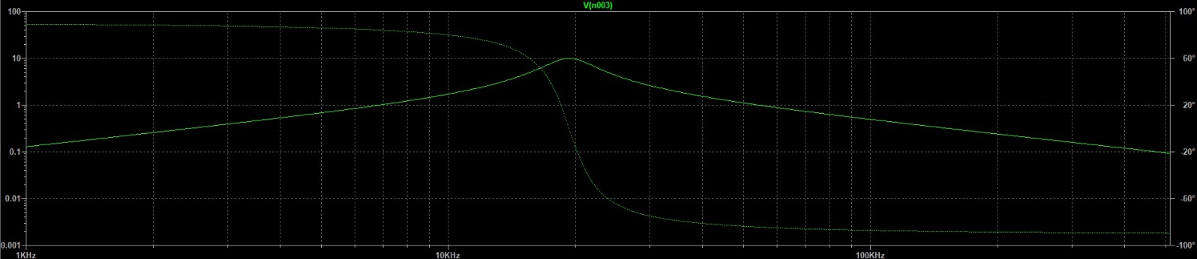

**Take note of the phase of Vo relative to Vi at the lowest, highest, and resonant frequencies.**

**Table 2:** Simulation of frequency response for circuit of **Fig 2**

|  |  |  |
| --- | --- | --- |
| $$f$$ | $$V_{o} (V)$$ | $$Phase (V_{o}/V_{i})$$ |
| $$1 kHz$$ | $$0.12851139$$ | $$89.263661°$$ |
| $$17.059321KHz$$ | $$7.07$$ | $$45.003614°$$ |
| $$19.292926KHz$$ | $$10$$ | $$0.17874027°$$ |
| $$21.835883KHz$$ | $$7.07$$ | $$-45.005591°$$ |
| $$512 kHz$$ | $$0.0933834$$ | $$-89.464943°$$ |

**_____ / 3**

**Lab Task 3**

Build a low pass filter (RC circuit) like that in lab task 1 with a cut off frequency around 120 Hz in LTspice. Since 120 Hz cut off frequency is rather low, you may choose a higher capacitance in this lab to minimize the resistance needed to obtain such a low cut off frequency. You will use this filter clean up the 10 kHz noise that is corrupting the music provided to you as a wave file for download (Lab4Music.wav). Save the LTspice schematic file and the wave file in the same folder.

1. First play the wave file directly to the loudspeaker.
2. Now supply the input of the filter circuit by pressing “Ctrl” on keyboard while right click the voltage source. Change the “Value” to below.

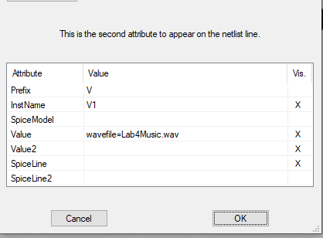

1. Press F4 or right-click to select draft and then “Label Net”. Name the nodal voltage corresponding to the voltage across the capacitor as “out”.
2. “Edit Simulation Command” and select “Transient”. The “Stop time” should be the duration of the original music.
3. Add an additional SPICE directive as: “.wave "test.wav" 16 44.1k V(out)”. Put the text anywhere on the schematic.
4. Run the simulation. A new wave file called “test.wav” will appear in the folder. Play “test.wav” and compare the sound with “Lab4Music.wav”.

If two signals of the same strength are applied to the input of the filter at the cut off frequency (*fc*) and at 10 kHz, at the output of the filter we will expect that the signal at 10 kHz relative to the signal at *fc* is:

☐ Reduced by around a factor of 10

☐ Reduced by around a factor of 100

☑ Increased by around a factor of 10

☐ No different

Chosen value of R: 1Ω

Chosen value of C: 1.325mF

Calculated value of *f*c based on chosen values of R and C:

$$f_{c}=\frac{1}{2πRC} \\ =\frac{1}{2π\left(1\right)\left(1.325×{10}^{-3}\right)} \\ =120.1169382Hz$$

**_______ / 4**